Eckert 16, energy expenditure.
Let op: a.d.h.v. powerpointpresentaties (dus niet complete hoofdstuk).
Bladzijde nummering niet 100% correct.

- Metabolism: sum chemical processes. Waste heat.
- Anabolic (assemblage) vs catabolic (breakdown → E). Energy perform work, chemical energy, lost heat. Heat production: index energy metabolism: metabolic rate.
- Basic metabolic rate (stable state minimal physiological and environmental stress, at body temperature), standard metabolic rate (~ at certain temperature), field metabolic rate (during normal activities). Because maintenance electrochemical homeostasis, protein synthesis, ATP. (Metabolic scope, ..)
- Direct calorimetry (when no chemical synthesis and no work): “calorimeter” (isolated chamber; e.g. via melted ice).
- Indirect colorimetry (energy intake – energy loss = MR; via combustion). Measuring via isotopes (how much loss labelled ↔ CO₂ production).
- Respirometry (measuring animal’s respiratory gas exchange; O₂ consumption: (1) relevant reactions aerobic, (2) consumption oxygen releases constant amount energy, (3) no lag).
- Respiratory quotient (R_{q}) = CO₂/O₂. Differs per food type, since other oxidized by-products.
- – 675. (..)
- Isometric scaling: all dimensions same scaling. Allometry (systematic change body proportions with increasing size). Smaller animal higher respiration rate.
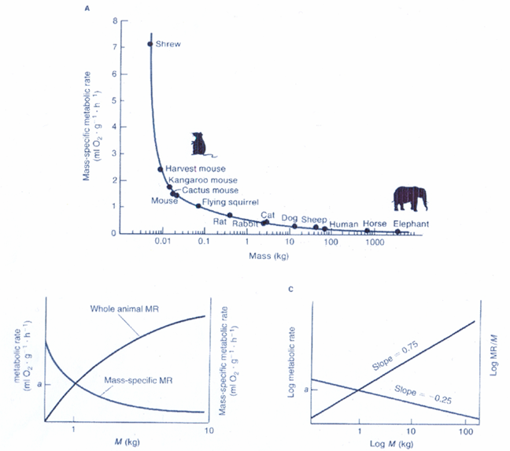
- MR = aM^{b} (M = mass, a = intercept log-log regression line, b = empirically determined rate change MR). [see figure].
- Heat loss ↔ surface. Surface area ^2/3 mass (^0.67; aka slope mss vs MR), though larger animals lower MR (16.8).
- – 695. (..)

